SOP for Resume Verification

Good quality resumes are highly important to obtain interview calls. This document lists the sections, content and other details required to verify candidate resumes. Following are the checklist for a good resume-

Header-
- Candidate’s name- in capital and increased size (15-16)
- Phone number (10 digits with country code) and professional E-Mail ID (consisting of your name) LinkedIn, GitHub and Portfolio profile links (Add full URL eg. https://www.linkedin.com/profile)
- Photographs are not essential for technical resumes (if added, ensure it’s a formal and professional one).
- Location may be added (check whether the location is in remote cities, if yes, remove it). Do not mention complete addresses (building/ flat number, should be avoided).

YOUR NAME
Ph. No. Email ID Location
LinkedIn GitHub Portfolio

Skills-
- Resumes should have a skills section consisting of all the relevant hard and soft skills.
- Categorize the skillsets into programming languages, tools, technologies
- Level of proficiency can also be indicated using terms such as ‘Basic’, ‘Intermediate’ and ‘Advanced/ Expert’. Avoid using bars/ stars or any graphical representation as it may hinder readability of content during online screenings.

Programming Languages : Python, Java
Web Technologies/ Frameworks : HTML, CSS, React.js, Angular
Database : MySQL, MongoDB
Technologies : Machine Learning, Artificial Intelligence
IDE : VS Code, Jupyter

Projects-
- Another important section for technical resumes (especially tech freshers). This section needs at least 3 best projects.
- Projects need to have:
1. A proper title e.g. Facial Expression Recognition Model/ Skill-Up- E-Learning Web Application.
2. Technologies/ Tools used to create the project need to be mentioned separately e.g. Power BI/ Machine Learning and Python.
3. A project description needs to be added consisting of the details of your project, the functionalities incorporated, results/ outcome achieved etc. Description should be short but specific (3-4 points).
4. Add a GitHub/ deployed link to the project.
5. What was your role in the project if it was a group project
6. Duration taken to build the project can also be added (optional)

Courses/ Certifications-
- List the relevant certifications here from recognised institutions or organizations.
- Include the courses done here as well (do not mention them under the Education section).
- Add the title of the certification, issuing organization and duration (e.g. Data Analysis with Python from IBM - Jan 2025)

Education-
- List educational qualifications in reverse chronological order starting with the highest qualification, so on and forth.
- If you have completed your Graduation then no need to mention 10th and 12th details
- Mention relevant course name, University/ College graduated from, year of passing and cumulative CGPA/ grades (if above 75%, if less than that, avoid mentioning)
- Bachelor of Technology in Computer Science (BTech CS) 2024
VJTI Mumbai - University of Mumbai 9.4 CGPA

Work Experience-
- Relevant experiences/ internships need to be listed properly in this section.
- Experience section needs to comprise of:
1. Title/ Designation working/ worked in
2. Name of the organization
3. Duration you’ve worked for
4. Major roles/ responsibilities or achievements

Awards/ Achievements (if any)

Format and other information-
- Template needs to be ATS friendly - consisting of a single column format. Too many graphics and pictures need to be avoided unless applying for creative fields/ roles.
- Resume pages need to be less than two. It is suggested that freshers create a single page resume while experienced professionals can have up to 2 pages.
- Font size should be consistent. 12px for headings and 10px for other contents
- Font styles should be professional and readable- Times New Roman, Arial, Calibri, EB Garamond, Helevetica are few suggested fonts.
- Dates should be mentioned in a standard, consistent format - Month, Year e.g. Nov 2024.
- Grammatical or spelling mistakes should be completely avoided. Proof read all sections before submitting.
- While listing any detailed content, it needs to be listed in concise bullet points. Ensure not to use pronouns such as I, my, mine etc. to mention the task done. Instead use action words (examples listed below) to describe it.
For e.g. if you want to mention a project that you have worked on, instead of writing ‘I have created a website where I added features like login…’, write ‘Designed a full stack web application, incorporating dynamic features such as login,…’
- The work/ responsibilities being done presently would be mentioned in present tense (develop, build, lead) and the work/ activities done in the past would be mentioned in past tense (developed, built, led).
- Quantify information wherever possible by sharing the result or impact your work has brought in e.g. accuracy rate of the model developed, percentage reduction in cost/ time etc.
- Key sections which you want to highlight can be italicised or made bold to make it stand out from the rest.
- Organize your resume in a way that the most relevant information (applicable to the job) is mentioned on the top most sections.

Action Verbs-
Action verbs are dynamic words that describe skills, experience, and accomplishments in a resume. They can help candidates stand out to potential employers. Here’s a list of action words for each skill category that can be used to enhance the resume:

Technical | Collaboration | Creative Skills | Management | Communication
- Developed  - Implemented  - Engineered  - Optimized  - Analyzed  - Designed  - Automated  - Programmed  - Troubleshot  - Integrated | - Coordinated  - Facilitated  - Partnered  - Contributed  - Unified  - Collaborated  - Supported  - Engaged  - Assisted  - Synergized | - Innovated  - Conceptualized  - Designed  - Brainstormed  - Crafted  - Revamped  - Visualized  - Produced  - Ideated  - Transformed | - Led  - Supervised  - Directed  - Oversaw  - Organized  - Delegated  - Mentored  - Streamlined  - Optimized  - Managed | - Presented  - Conveyed  - Articulated  - Negotiated  - Drafted  - Clarified  - Advocated  - Documented  - Facilitated  - Explained

E.g. Developed a software/app using (technologies)...
Designed and implemented a tool/system that…

Resume Examples- Experienced
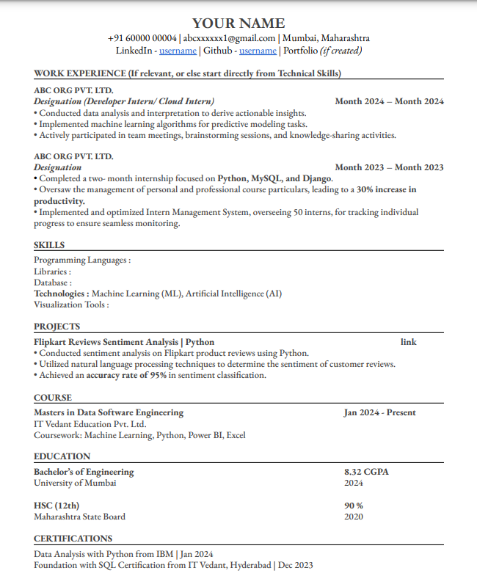

Fresher-

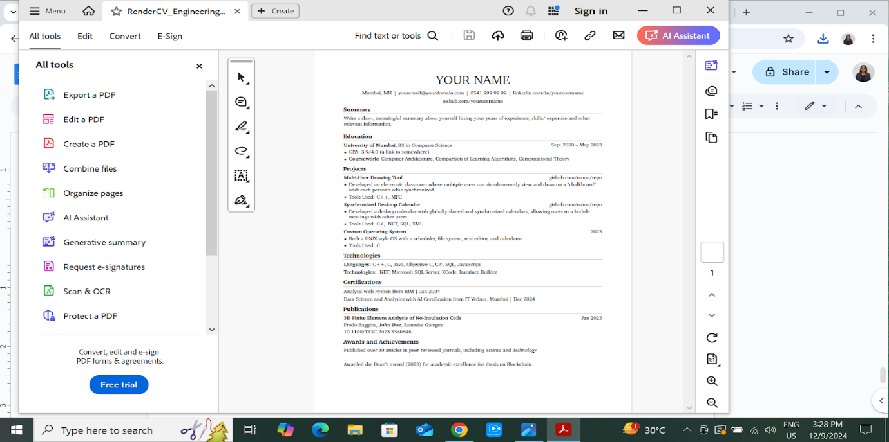
The above listed resumes are for reference purposes. Tailor your resume according to your skillsets and qualifications. If you are listing any non- technical work experience which is not related to the role that you're applying for, ensure that the experience is not listed on top. You can list them at the bottom or towards the end.

Few websites to create ATS friendly resumes-
- https://resumeworded.com/resume-templates
- https://www.overleaf.com/latex/templates

